

**Fatal Crash Response Coordination Committee – VZ Dashboard Links**

Vision Zero Dashboards from other cities are listed below for reference with salient features of each of the dashboards listed as bullet points.

IDOT Dashboard: <http://apps.dot.illinois.gov/fatalcrash/snapshot.html>

* At a glance window (high profile attributes)
* Key terms window
* Ability to view past years’ data

​​​​​​

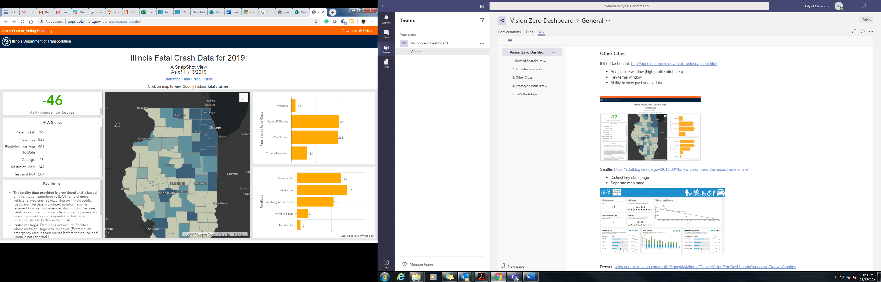

Seattle: <https://sdotblog.seattle.gov/2016/06/10/new-vision-zero-dashboard-now-online/>

* Distinct key stats page
* Separate map page

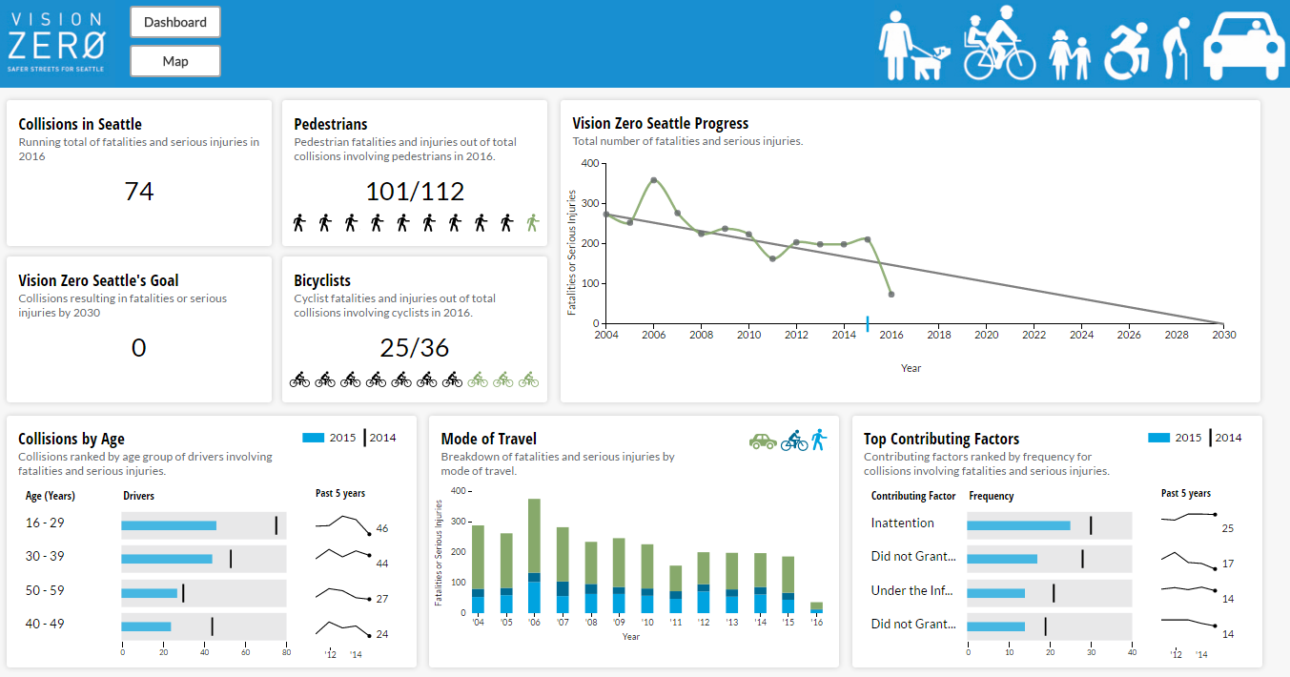

Denver: <https://public.tableau.com/profile/kmay#!/vizhome/DenverVisionZeroDashboard/OverviewofDenverCrashes> | <https://www.denvergov.org/content/denvergov/en/vision-zero/dashboard.html>

* Multiple attributes graphed
* Nominal map with just points
* Graphs only for KSI

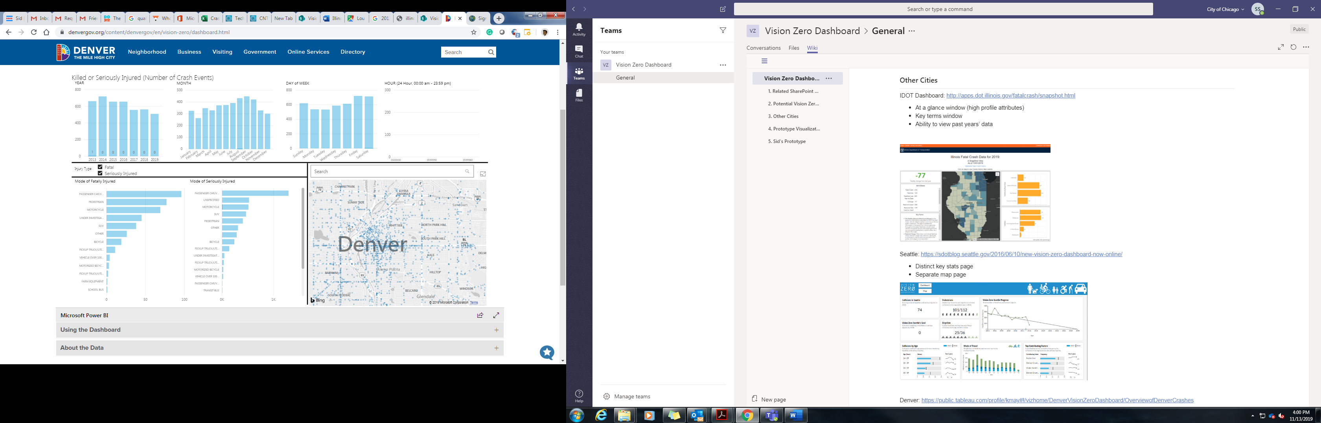

Portland:

<https://www.portlandoregon.gov/transportation/40390>

<https://pdx.maps.arcgis.com/apps/MapSeries/index.html?appid=47c2153a3fa84636bb63e25b451372d0>

* High Crash Corridors mapped
* Crashes mapped, can click on each for more information
* Allows filtering of data

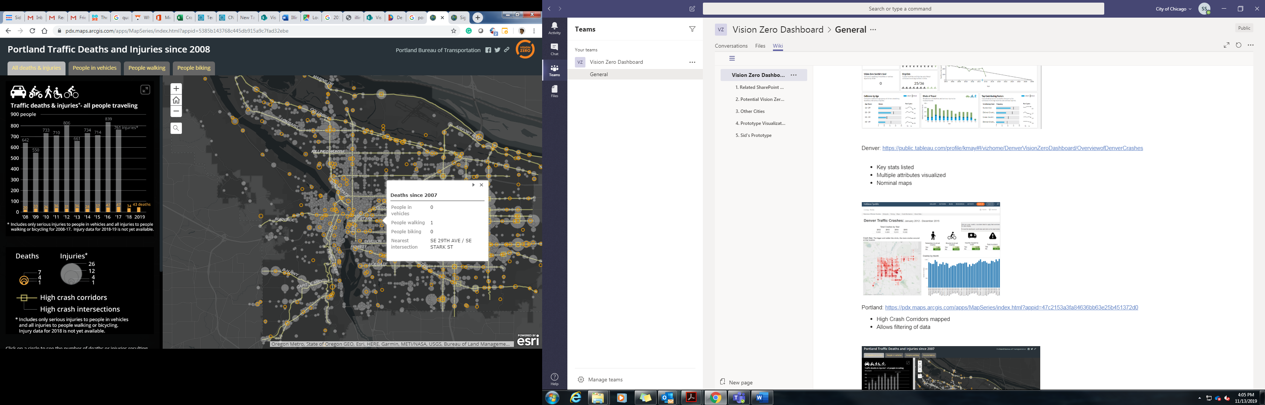

NYC: <http://coolmaps.esri.com/#13>

* Citizen created
* Cool visualization
* No helpful stats/filtering

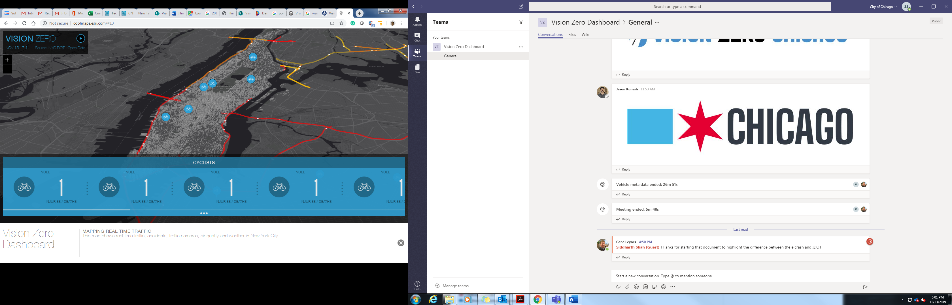

DC: <https://www.dcvisionzero.com/maps-data>

* Statistical Analysis w/map
* Visualized Stats
* Allows filtering of data

Data from: <https://opendata.dc.gov/datasets/crashes-in-dc?geometry=-77.064%2C38.900%2C-77.033%2C38.906>

​​​​​​

SFO: <https://www.visionzerosf.org/maps-data/>

* High Crash Network mapped separately
* Monthly summary report

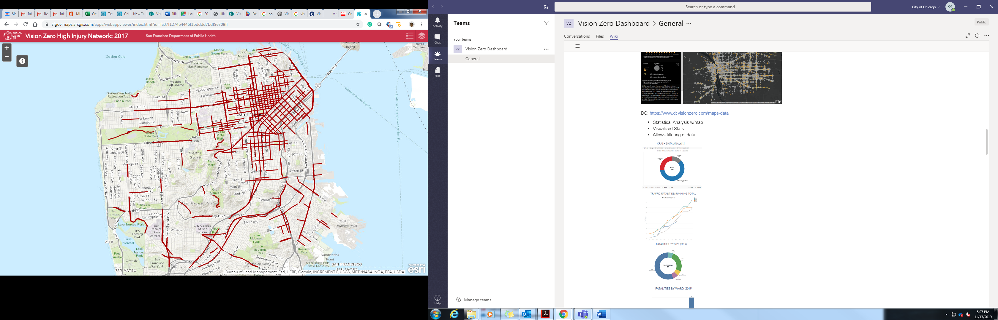

LA: <http://visionzero.geohub.lacity.org/>

* High Crash Network mapped
* Community Data
* Crashes animated over time
* Link to data download

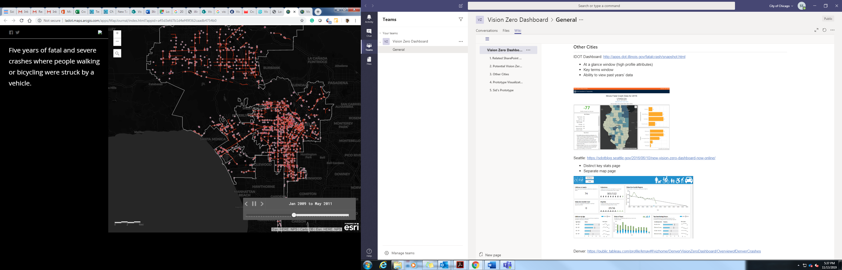

Denver: <https://geospatialdenver.maps.arcgis.com/apps/MapJournal/index.html?appid=e333ca7679ec40c2a3ef449e3b111743>

* Socioeconomics vs. High crash areas mapped

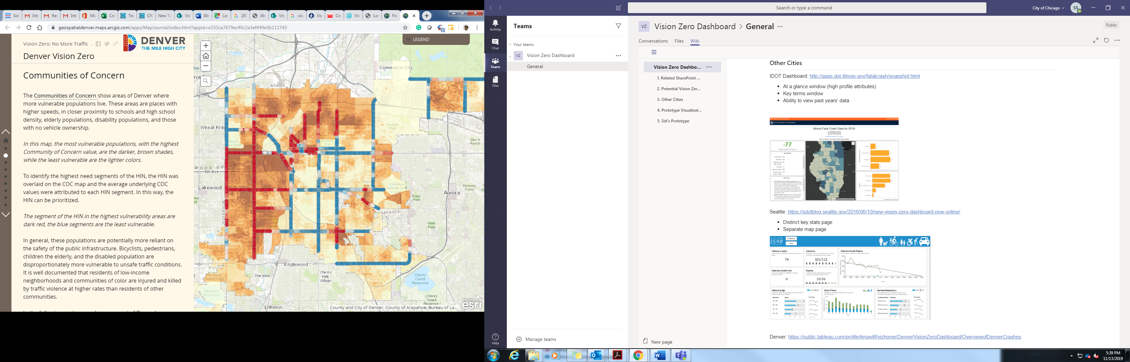

Toronto: <https://www.toronto.ca/services-payments/streets-parking-transportation/road-safety/vision-zero/safety-measures-and-mapping/>

* Allows filtering by geographies
* Safety improvements mapped

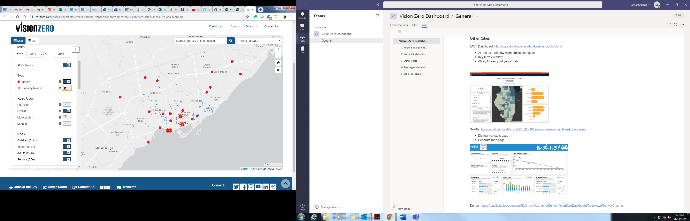

NY: <http://www.nycvzv.info/>

* Statistics with map
* Street improvement information
* Public input option
* Ability to download data

NY: <http://crashmapper.org/#/>

* Allows filtering by time & geography

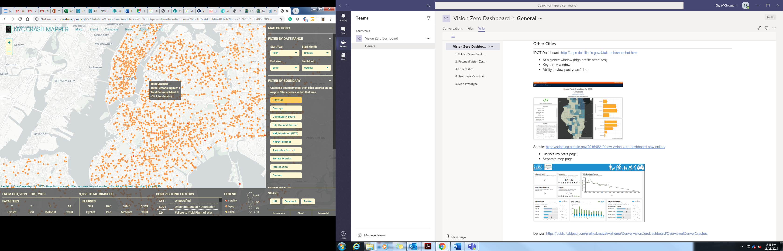

What VZC dashboard could be:

<https://siddharthsilver.wixsite.com/fatalcrashdashboard>